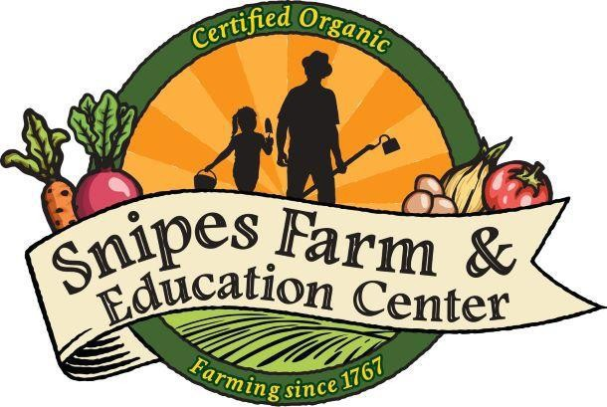*Sustainable farming, building community and reconnecting people to the land*

CSA MEMBER HANDBOOK 2022

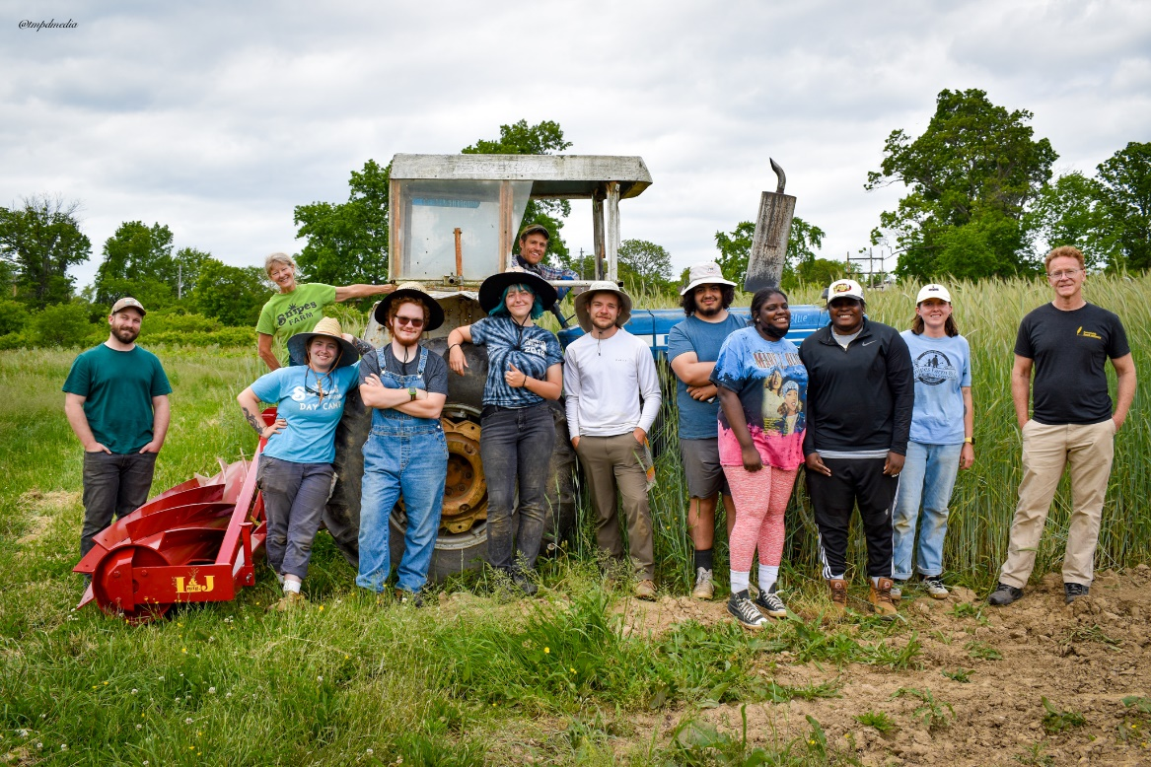

# 

# Welcome to the 2022 growing season at Snipes Farm and Education Center CSA

Thank you for joining our farm! **Our crops are PCO** (Pennsylvania Certified Organic) and **USDA**

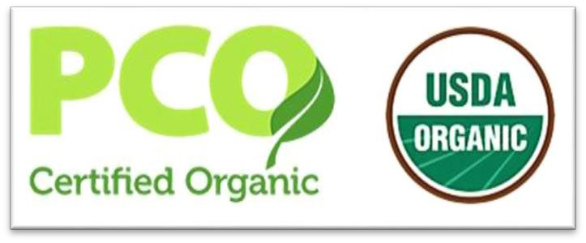(U.S. Dept. of Agriculture) **Certified Organic.** The certification is viewable in our CSA barn. Please read this handbook carefully and keep it for future reference. This handbook, along with the weekly email newsletters and the website, will provide you with all the information you need to make your experience at our farm a good one.

# Email Newsletter

During the harvest season, you’ll receive a weekly email with news from the farm, announcements, recipes, expected harvest and more! This is your best source for keeping up to date with the goings on at the farm, so please read it carefully each week. If you have supplied your email address to the farm you will automatically receive a weekly email.

# Contact Information

**Website:** [www.snipesfarm.org](http://www.snipesfarm.org/) **Director of Farming:** Victoria Lautsbaugh-Gorman **Field Manager:** Peter Crooke

**Farm Staff:** Denise, Ella, Nicole, Tara, Emma, Rich, Jeremy, and Edy

**Office contact:** Michele Mullaney 215-295-1138 x103

# Snipes Farm and Education Center (SFEC)

Founded as a nonprofit in 2008, Snipes Farm and Education Center’s “outdoor classroom” is located on 25 acres of historic Snipes Farm in Morrisville, Pennsylvania. SFEC envisions a world where everyone has access to healthy food, open space and the experience of farming, where local economies are strengthened by the preservation of small farms, and where priority is given to sustaining the earth and its natural resources. Our work in the community includes a Community Supported Agriculture program (CSA), farm to school programs with local school children, summer camp and agriculture workshops through the winter. By partnering with local charitable organizations, we are able to donate 70% of the food we grow to people in need.

# How does the CSA at Snipes Farm and Education Center work?

Community Supported Agriculture (CSA) is a partnership between a local farm and a community of supporters. Supporters help cover the farmʼs yearly operating budget by purchasing a share of the seasonʼs harvest. Members through their CSA purchase help assume the costs, risks, and bounty of growing food. Members help pay for seeds, greenhouse and field costs, water, labor, and equipment maintenance.

The founding members of our CSA were deeply concerned about pesticide use in industrial agriculture and the availability of locally grown food and had a desire to support local agriculture. They were excited about a new CSA at Snipes Farm and were willing to pre-pay for their share in anticipation of the season’s harvest.

We use no GMO products, no synthetic pesticides, herbicides, or fertilizers. We start with organic seed and utilize a rotation and soil management plan. In return, the farm provides, to the best of its ability, a healthy supply of seasonal, fresh produce to CSA members throughout the growing season. This mutually- supportive relationship helps create an economically-stable, sustainable local farm operation, encouraging a healthy environment and responsible land stewardship.

# 

# Directions

Snipes Farm and Education Center is located at 890 West Bridge Street, Morrisville, PA 19067. For directions to the farm please visit our website at [www.snipesfarm.org.](http://www.snipesfarm.org/)

# PICK-UP TIMES:

THURSDAYS 3:00 pm – 7:00 pm **RAIN OR SHINE** at the farm

SATURDAYS 9:00 am – 1:00 pm **RAIN OR SHINE** at the Market on Snipes Farm in the Big Red Barn

**U-PICK TIMES:**

THURSDAYS 3:00 pm – 7:00 pm **RAIN OR SHINE**

**Feel free to visit the farm animals.**

# CSA Pick-up Guidelines - Our season runs from June into November.

1. **Parking:** Follow CSA signs to park for weekly distribution. Park and follow walking signs to the upper side of the barn.
2. **Bring Your Own Bags:** We do not supply bags for picking up your produce. Please bring baskets, bags or a cooler to transport your vegetables home.
3. **Traditional Share Members:** Please make sure to check off your name on the clip board when picking up the share we have packed for you.
4. **Market Share Members:** Please go to the CSA barn and staff will help you select your veggies using your market card.

**Traditional Full Share:** $800 - Members pick up 8 to 12 items of produce weekly as selected by the farmer.

**Traditional Half Share**: $450 - Members pick up 8 to 12 items of produce every other week as selected by the farmer.

**Market Share Levels:** $700, $400, $200 - Members can select veggies of their own choice.

* + **$700 Family Share** serves 4 to 5 people
  + **$400 Standard Share** serves 2 to 3 people
  + **$200 Mini Share serves** 1 to 2 people

Market share members will receive a Market Card with the value of their share on it when they attend their first CSA distribution day. They will then use their cards to "purchase" their produce. Market cards may also be used for farm-fresh eggs and other value-added products when available. Market cards may be used at the Snipes Farm CSA barn on Thursdays 3-7 or at Snipes Farm in the Big Red Barn on Saturdays 9-1.

**Please note:** Our expectation is that each Market Share member will fully utilize the funds on their market share card by the end of the season in the year it was purchased. Market Card funds not utilized by the end of season cannot be carried over to the subsequent year, but they will be used to provide healthy organic food local families in need.

# 

# Pick-your-own crops

In addition to picking up your produce from the barn there are designated pick-your-own crops in the field. These include but are not limited to: all perennial herbs such as peppermint and oregano, flowers, cherry tomatoes, hot peppers, beans and sugar snap peas.

On the day of pick-up please inquire about any opportunities to pick-your-own produce. **Please read the Pick-Your-Own board carefully.**

Once in the field or orchard, look for markers designating what and where you should pick.

# What to bring for pick-your-own

Please bring along scissors or a sharp knife, a container with water for flowers, baskets for your pickings, hat, sunscreen and a water bottle.

# 

# Conflicts on your pick-up day? On vacation?

If you are not able to pick up your produce, you have two options for what to do with the harvest:

* **Give your produce away** – to a friend, relative, someone you think might want to join our farm next year. This is by far the best way of advertising for our farm. You do not need to tell us if someone else will be picking up for you, but please let your replacement read this handbook and give them any additional instructions.
* **If someone is picking up for you** please tell them to check your off name!
* **Donate your produce -** Each week many shares are donated to the Bucks County Emergency Homeless Shelter. These shares are made possible by donations from our CSA members and other donors. Please let us know in advance if you wish your share to be added to one of these groups’ weekly pick-ups.

***Safety at the farm – READ THIS PLEASE!!!!***

1. Wearing masks is voluntary at this time. If we go through another spike in cases, you may be required to wear a mask in any indoor places.
2. Please supervise your children at all times. Do not let children play on or near any farm equipment or approach farm animals without supervision of staff. Please keep track of children while picking in the fields.
3. Drive slowly, under 10 miles per hour, and be mindful of children and small animals.
4. Watch your step – look out for holes, ruts and irrigation. Wear sturdy shoes.
5. Please do not enter the animal pens.
6. Remember your “farm kit” for pick-your-own and volunteer hours: (hat, gloves, sunscreen, water bottles, scissors, bags/boxes).
7. SPECIAL REQUEST FROM THE FARMERS: Please refrain from smoking in the fields, so that everyone can enjoy the fresh air and serenity of our beautiful farm.

**While on the farm you are welcome to visit our playground,**

**and please take a walk on our nature trail!**

**Volunteer Opportunities**

Each CSA member is invited to volunteer during the growing season. This work is fulfilling, a great family activity, and a terrific community builder!

To volunteer, visit our website and click on volunteer.

We would love to see you soon!

**WE ARE LOOKING FORWARD TO A BOUNTIFUL SEASON!!**

**~ ~ ~**

**Join the movement!**

**Support local farming in Bucks County**

**Enjoy healthy food for the entire growing season from June to November.**

**Buy fresh, buy local!**